**SWAN Report**

**FYP Group Work, Understanding their work**

The FYP group initialized the work on the SWAN software and provided MATLAB scripts that allow the automation of the generation of the SWAN input files. The scripts were based on bathymetry available online by GEBCO, wind data form wind forecast specifically over all the Lebanese territory done by Dr. Lakkis from the AUB, and the wave data available from Isramar.

The simulation was based on a coarse regulation computational grid, coarse input data, and coarse bathymetry. The results are not valid near shore are can only be used as a validation of the simulation process using the SWAN software.

**Validation on a simple grid regarding input grids size: bathymetry, wind, and computation grids.**

Based on the work of the FYP, the available MATLAB scripts were used and modified to match the structure of the data available from CYCOFOS- Cyprus coastal ocean forecasting system; also, additional features were added to the coded so that they are more organized, flexible and robust.

The coordinate system for input and output wind and wave data should be unique. For the current simulation, the Cartesian coordinate system is used.

**Validation of the use of the boundary condition.**

The wind and wave input files should contain no values, and the wave boundary condition values are sensitive to zero values for the period.

**Description of the available data from CYCOFOS**

CYCOFOS provided hourly-based data in the netCFD format for a period of two weeks starting from April 18 2016. The data includes bathymetry, longitude and latitude, wind speed and direction, significant wave height, wave period, wave mean and peak direction, u and v surface current and more.

Bathymetry

The bathymetry available from CYCOFOS is an interpolation of the GEBCO data, so that it is relatively finer.

**Validation of wind and wave directions predicted by our own simulation with CYCOFOS data.**

??

**Using Triangle 2D mesh generator along with BatTri toolbox to generate the unstructured Mesh.**

Description of the process and achieved results.

To be able to have valid results near-shore, it is important to use a finer grid. An unstructured grid is more efficient that a regular grid since it will have finer meshing only in required areas. For this purpose Triangle, a Two-Dimensional Quality Mesh Generator and Delaunay Triangulator, is used. Along with the BatTri MATLAB toolbox, a smart mesh is generated where finer mesh is created for the low-depth (near-shore) regions. The unstructured mesh includes about 18k grid point while the structured mesh with the same resolution of the input data will include only about 12k grid point. The increase in grid points number is only about 50%, while a fine grid is achieved and the distance between the grid points in the coarse region were kept as close as possible to that of the structured grid.

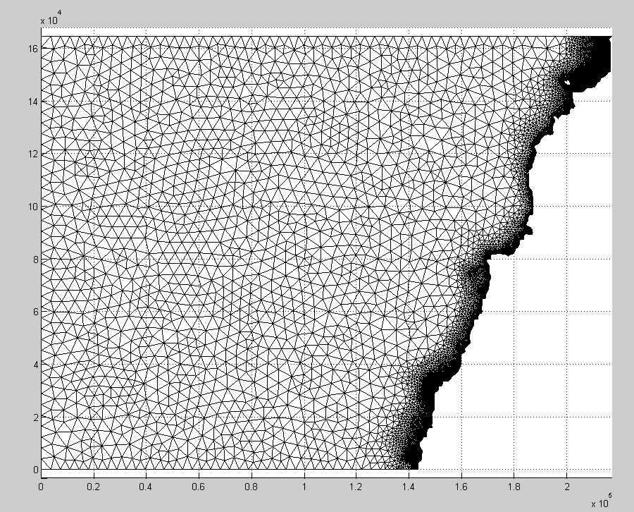

**Results**

In April, 25th 2016 morning a transition in wave direction occurs: wave coming from the north are overcome by the wave coming from the west. CYCOFOS data and our preliminary simulation predict this transition differently.

**Plots of the data from CYCOFOS**

The transition in wave direction starts at 9:00 am (~350 deg) and peaks at 11:00 am (~250 deg) in the buoy deployment area (AUB shores).

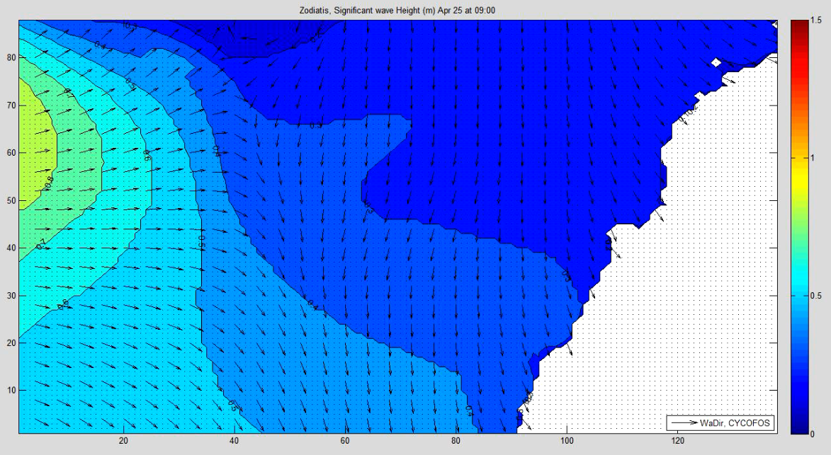

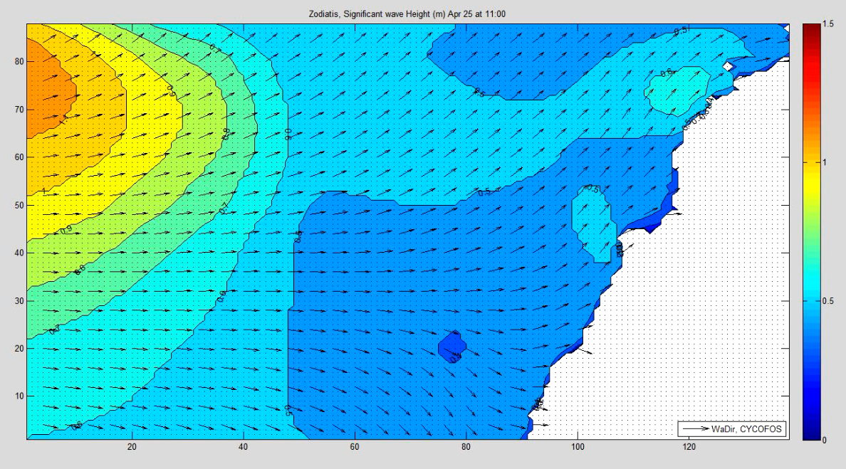

**Results acquired from the regular computational grid**

The transition in wave direction starts at 8:00 am (~350 deg) and peaks at 11:00 am (~250 deg) in the buoy deployment area (AUB shores).

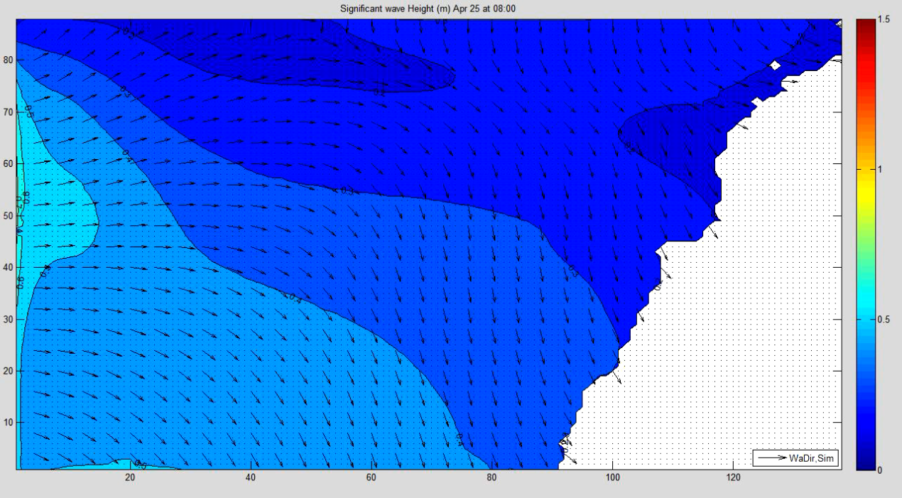

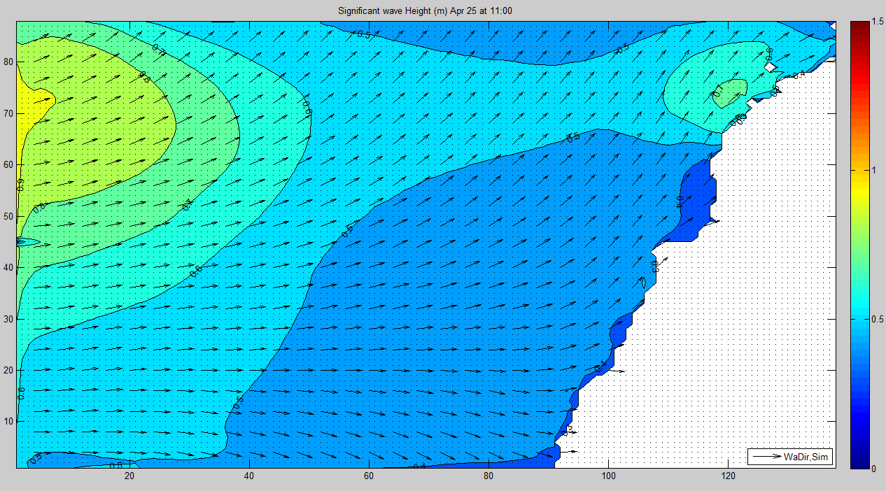

**Measurement Data**

The first measurement is done at 9:30 am, and give 345deg, which is quite reasonable, and just start dropping at 11:00 am, and reaches 290deg at 2:00 pm.

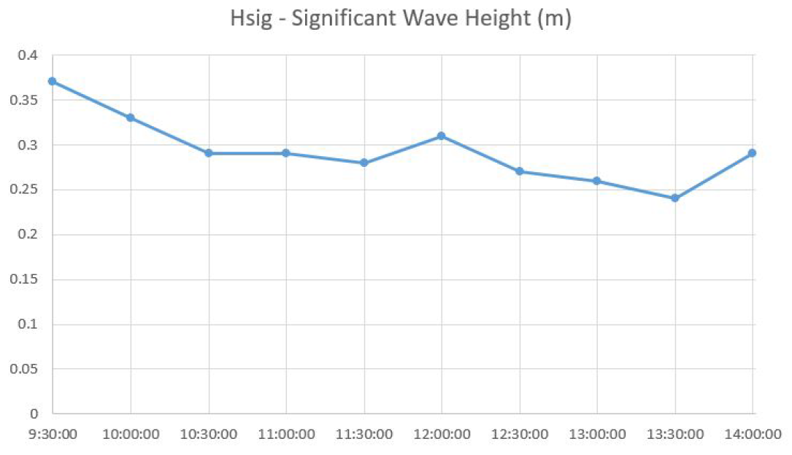

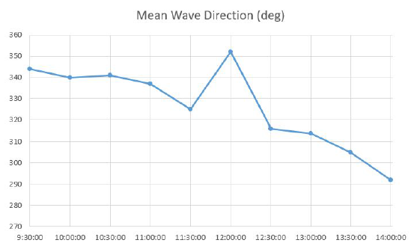

**Comparison of the results acquired from the high-resolution unstructured computational grid and the regular grid.**

CYCOFOS: Slower propagation in wave direction, faster propagation in significant wave height.

Simulation: Faster propagation in wave direction, slower propagation in significant wave height.

Our simulation was run at April 25th 00:00, which is only 8-9 hours earlier than the transition time; that limited time might insufficient to achieve the steady state of the system. Also, the currents are still not included in our models.

Buoy Data can only give an approximation for comparison with Simulation data, since the buoy was placed in near-shore area, where the simulation results will have lack of accuracy.

What can be said is that the predicted significant wave height and wave direction are both reasonable, and further interpretation at the moment can be misleading.

**Addition commands to SWAN: ??**

**Future work:**

Using current data to enhance the wave propagation and direction results.

Use of nautical grid.

Use of the SWAN plots MATLAB toolbox.

Use of the coastal line to generate the computational grid.

Apply the simulation to a longer period.

Apply a nested simulation.